**BANK MANAGEMENT SYSTEM**

*Mini Project Report*

*Submitted in partial fulfilment of the*

*Requirements for the award of the Degree of*

**BACHELOR OF ENGINEERING**

IN

**INFORMATION TECHNOLOGY**

By

**FOUZAN AHMED 1602-19-737-011**

**K.SHIVA KASI REDDY 1602-19-737-041**



**Department of Information Technology**

**Vasavi College of Engineering (Autonomous)**

**(Affiliated to Osmania University)**

**Ibrahimbagh, Hyderabad-31**

**2020**

**Vasavi College of Engineering (Autonomous)**

**(Affiliated to Osmania University)**

**Hyderabad-500 031**

**Department of Information Technology**



**DECLARATION BY THE CANDIDATE**

We, **FOUZAN and SHIVA KASI REDDY,** bearing hall ticket number*s* **1602-19-737-011,1602-19-737-041**, hereby declare that the project report entitled **“BANK MANAGEMENT SYSTEM”** Department of Information Technology, Vasavi College of Engineering, Hyderabad, is submitted in partial fulfilment of the requirement for the award of the degree of **Bachelor of Engineering** in **Information Technology**

This is a record of bonafide work carried out by me and the results embodied in this project report have not been submitted to any other university or institute for the award of any other degree or diploma.

**FOUZAN AHMED**

**1602-19-737-011**

**K.SHIVA KASI REDDY**

**1602-19-737-041**

(Faculty In-Charge) (Head,Dept of IT)

**ACKNOWLEDGEMENT**

We, Fouzan and Shiva Kasi presenting you "Bank Management system" mini projectreport as per the curriculum of B.E second semester.

We express our sincere thanks to Dr. K .Ram Mohan Rao Sir (HOD) of IT department , Vasavi college of engineering , Hyderabad for providing us this golden opportunity to prepare the project. We are immensely obliged to our seniors for their elevating inspiration, encouraging guidance and kind supervision in the completion of our project.

We feel to acknowledge our indebtedness and deep sense of gratitude to our guide Ms. Leelavathy whose valuable guidance and kind supervision give to us throughout the practice which shaped the present work as its show.

**ABSTRACT**

The Bank Management System is based on maintaining a person’s account in a bank . In this project we are trying to show the working of a banking account system and cover the basic functionality of a Bank Account Management System . It manages all the transactions like new account entry,deposits as well as withdraw money, loan entry, managing bills or cheque etc..Thus above features of this software will save transaction time and increase the efficiency of the System.

The project analyzes the system requirements and then comes up with the requirements specifications. It studies other related systems and then come up with system specifications. The system is then designed in accordance with specifications to satisfy the requirements. The system design is then implemented with MYSQL, PHP and HTML. The system is designed as an interactive and content management system. The content management system deals with data entry, validation confirm and updating whiles the interactive system deals with system interaction with the administration and users.

**INTRODUCTION**

Bank Management System is based on a concept to generate and maintain daily payment transactions with the customer’s account. Before stepping into the main system a user has to pass through login system to get access, then only he/she can use all the features of the system which includes Adding, Removing, Updating and viewing records, withdraw and deposit cash feature, check details of existing customers and Talking about the features of Bank Management System, while entering customer’s record he/she has to provide the current date, account number, name, date of birth, age, address, citizenship number, phone number, the amount deposited while creating an account and select account type. Under this, there are five types of account, Saving, Current, Fixed(for 1 year), Fixed(for 2 years), Fixed(for 3 years). But while updating customer’s information from existing account, he/she can only change address and phone number. There are two methods to check a user’s account in detail i.e by Account number or by Account name. The other listing record displays customer’s name with an Account number, address and contact detail.

**TECHNOLOGY**

1. **Software Requirements**

Software requirements deal with defining software resource requirements and pre-requisites that need to be installed on a computer to provide optimal functioning of an application. These requirements or pre-requisites are generally not included in the software installation package and need to be installed separately before the software is installed.

Software requirements for this project are :

Operating System: Windows 10

Development tools: Vim editor, GCC compiler

These software requirements helped us to write our code efficiently and easily.

1. **Hardware Requirements**

The most common set of requirements defined by any operating system or software application is the physical computer resources, also known as hardware. A hardware requirements list is always accompanied by a hardware compatibility list(HCL), especially in case of operating systems. An HCL lists tested, compatibility and sometimes incompatible hardware devices for a particular operating system or application

Hardware requirements for present project are:

Processor : Intel Core i5

Main Memory(RAM) : 256 MB

Cache Memory : 512 KB

**PROPOSED WORK**

**a.Design**

**Use Case Diagram**

1. **Implementation:-**

https://github.com/Fouzanahmedjaved/Bank-Management

**#include<stdio.h>**

**#include<stdlib.h>**

**#include<windows.h>**

**int i,j;**

**int main_exit;**

**void menu();**

**struct date{**

**int month,day,year;**

**};**

**struct {**

**char name[60];**

**int acc_no,age;**

**char address[60];**

**char citizenship[15];**

**double phone;**

**char acc_type[10];**

**float amt;**

**struct date dob;**

**struct date deposit;**

**struct date withdraw;**

**}add,upd,check,rem,transaction;**

**float interest(float t,float amount,int rate)**

**{**

**float SI;**

**SI=(rate*t*amount)/100.0;**

**return (SI);**

**}**

**void fordelay(int j)**

**{ int i,k;**

**for(i=0;i<j;i++)**

**k=i;**

**}**

**void new_acc()**

**{**

**int choice;**

**FILE *ptr;**

**ptr=fopen("record.dat","a+");**

**account_no:**

**system("cls");**

**printf("\t\t\t\xB2\xB2\xB2\ ADD RECORD \xB2\xB2\xB2\xB2");**

**printf("\n\n\nEnter today's date(dd/mm/yyyy):");**

**scanf("%d/%d/%d",&add.deposit.day,&add.deposit.month,&add.deposit.year);**

**printf("\nEnter the account number:");**

**scanf("%d",&check.acc_no);**

**while(fscanf(ptr,"%d %s %d/%d/%d %d %s %s %lf %s %f %d/%d/%d\n",&add.acc_no,add.name,&add.dob.month,&add.dob.day,&add.dob.year,&add.age,add.address,add.citizenship,&add.phone,add.acc_type,&add.amt,&add.deposit.month,&add.deposit.day,&add.deposit.year)!=EOF)**

**{**

**if (check.acc_no==add.acc_no)**

**{printf("Account no. already in use!");**

**fordelay(1000000000);**

**goto account_no;**

**}**

**}**

**add.acc_no=check.acc_no;**

**printf("\nEnter the name:");**

**scanf("%s",add.name);**

**printf("\nEnter the date of birth(dd/mm/yyyy):");**

**scanf("%d/%d/%d",&add.dob.day,&add.dob.month,&add.dob.year);**

**printf("\nEnter the age:");**

**scanf("%d",&add.age);**

**printf("\nEnter the address:");**

**scanf("%s",add.address);**

**printf("\nEnter the Adhaar number:");**

**scanf("%s",add.citizenship);**

**printf("\nEnter the phone number: ");**

**scanf("%lf",&add.phone);**

**printf("\nEnter the amount to deposit:Rs");**

**scanf("%f",&add.amt);**

**printf("\nType of account:\n\t#Saving\n\t#Current\n\t#Fixed1(for 1 year)\n\t#Fixed2(for 2 years)\n\t#Fixed3(for 3 years)\n\n\tEnter your choice:");**

**scanf("%s",add.acc_type);**

**fprintf(ptr,"%d %s %d/%d/%d %d %s %s %lf %s %f %d/%d/%d\n",add.acc_no,add.name,add.dob.month,add.dob.day,add.dob.year,add.age,add.address,add.citizenship,add.phone,add.acc_type,add.amt,add.deposit.month,add.deposit.day,add.deposit.year);**

**fclose(ptr);**

**printf("\nAccount created successfully!");**

**add_invalid:**

**printf("\n\n\n\t\tEnter 1 to go to the main menu and 0 to exit:");**

**scanf("%d",&main_exit);**

**system("cls");**

**if (main_exit==1)**

**menu();**

**else if(main_exit==0)**

**close();**

**else**

**{**

**printf("\nInvalid!\a");**

**goto add_invalid;**

**}**

**}**

**void view_list()**

**{**

**FILE *view;**

**view=fopen("record.dat","r");**

**int test=0;**

**system("cls");**

**printf("\nACC. NO.\tNAME\t\t\tADDRESS\t\t\tPHONE\n");**

**while(fscanf(view,"%d %s %d/%d/%d %d %s %s %lf %s %f %d/%d/%d",&add.acc_no,add.name,&add.dob.month,&add.dob.day,&add.dob.year,&add.age,add.address,add.citizenship,&add.phone,add.acc_type,&add.amt,&add.deposit.month,&add.deposit.day,&add.deposit.year)!=EOF)**

**{**

**printf("\n%6d\t %10s\t\t\t%10s\t\t%.0lf",add.acc_no,add.name,add.address,add.phone);**

**test++;**

**}**

**fclose(view);**

**if (test==0)**

**{ system("cls");**

**printf("\nNO RECORDS!!\n");}**

**view_list_invalid:**

**printf("\n\nEnter 1 to go to the main menu and 0 to exit:");**

**scanf("%d",&main_exit);**

**system("cls");**

**if (main_exit==1)**

**menu();**

**else if(main_exit==0)**

**close();**

**else**

**{**

**printf("\nInvalid!\a");**

**goto view_list_invalid;**

**}**

**}**

**void edit(void)**

**{**

**int choice,test=0;**

**FILE *old,*newrec;**

**old=fopen("record.dat","r");**

**newrec=fopen("new.dat","w");**

**printf("\nEnter the account no. of the customer whose info you want to change:");**

**scanf("%d",&upd.acc_no);**

**while(fscanf(old,"%d %s %d/%d/%d %d %s %s %lf %s %f %d/%d/%d",&add.acc_no,add.name,&add.dob.month,&add.dob.day,&add.dob.year,&add.age,add.address,add.citizenship,&add.phone,add.acc_type,&add.amt,&add.deposit.month,&add.deposit.day,&add.deposit.year)!=EOF)**

**{**

**if (add.acc_no==upd.acc_no)**

**{ test=1;**

**printf("\nWhich information do you want to change?\n1.Address\n2.Phone\n\nEnter your choice(1 for address and 2 for phone):");**

**scanf("%d",&choice);**

**system("cls");**

**if(choice==1)**

**{printf("Enter the new address:");**

**scanf("%s",upd.address);**

**fprintf(newrec,"%d %s %d/%d/%d %d %s %s %lf %s %f %d/%d/%d\n",add.acc_no,add.name,add.dob.month,add.dob.day,add.dob.year,add.age,upd.address,add.citizenship,add.phone,add.acc_type,add.amt,add.deposit.month,add.deposit.day,add.deposit.year);**

**system("cls");**

**printf("Changes saved!");**

**}**

**else if(choice==2)**

**{**

**printf("Enter the new phone number:");**

**scanf("%lf",&upd.phone);**

**fprintf(newrec,"%d %s %d/%d/%d %d %s %s %lf %s %f %d/%d/%d\n",add.acc_no,add.name,add.dob.month,add.dob.day,add.dob.year,add.age,add.address,add.citizenship,upd.phone,add.acc_type,add.amt,add.deposit.month,add.deposit.day,add.deposit.year);**

**system("cls");**

**printf("Changes saved!");**

**}**

**}**

**else**

**fprintf(newrec,"%d %s %d/%d/%d %d %s %s %lf %s %f %d/%d/%d\n",add.acc_no,add.name,add.dob.month,add.dob.day,add.dob.year,add.age,add.address,add.citizenship,add.phone,add.acc_type,add.amt,add.deposit.month,add.deposit.day,add.deposit.year);**

**}**

**fclose(old);**

**fclose(newrec);**

**remove("record.dat");**

**rename("new.dat","record.dat");**

**if(test!=1)**

**{ system("cls");**

**printf("\nRecord not found!!\a\a\a");**

**edit_invalid:**

**printf("\nEnter 0 to try again,1 to return to main menu and 2 to exit:");**

**scanf("%d",&main_exit);**

**system("cls");**

**if (main_exit==1)**

**menu();**

**else if (main_exit==2)**

**close();**

**else if(main_exit==0)**

**edit();**

**else**

**{printf("\nInvalid!\a");**

**goto edit_invalid;}**

**}**

**else**

**{printf("\n\n\nEnter 1 to go to the main menu and 0 to exit:");**

**scanf("%d",&main_exit);**

**system("cls");**

**if (main_exit==1)**

**menu();**

**else**

**close();**

**}**

**}**

**void transact(void)**

**{ int choice,test=0;**

**FILE *old,*newrec;**

**old=fopen("record.dat","r");**

**newrec=fopen("new.dat","w");**

**printf("Enter the account no. of the customer:");**

**scanf("%d",&transaction.acc_no);**

**while (fscanf(old,"%d %s %d/%d/%d %d %s %s %lf %s %f %d/%d/%d",&add.acc_no,add.name,&add.dob.month,&add.dob.day,&add.dob.year,&add.age,add.address,add.citizenship,&add.phone,add.acc_type,&add.amt,&add.deposit.month,&add.deposit.day,&add.deposit.year)!=EOF)**

**{**

**if(add.acc_no==transaction.acc_no)**

**{ test=1;**

**if(strcmpi(add.acc_type,"fixed1")==0||strcmpi(add.acc_type,"fixed2")==0||strcmpi(add.acc_type,"fixed3")==0)**

**{**

**printf("\a\a\a\n\nYOU CANNOT DEPOSIT OR WITHDRAW CASH IN FIXED ACCOUNTS!!!!!");**

**fordelay(1000000000);**

**system("cls");**

**menu();**

**}**

**printf("\n\nDo you want to\n1.Deposit\n2.Withdraw?\n\nEnter your choice(1 for deposit and 2 for withdraw):");**

**scanf("%d",&choice);**

**if (choice==1)**

**{**

**printf("Enter the amount you want to deposit:Rs ");**

**scanf("%f",&transaction.amt);**

**add.amt+=transaction.amt;**

**fprintf(newrec,"%d %s %d/%d/%d %d %s %s %lf %s %f %d/%d/%d\n",add.acc_no,add.name,add.dob.month,add.dob.day,add.dob.year,add.age,add.address,add.citizenship,add.phone,add.acc_type,add.amt,add.deposit.month,add.deposit.day,add.deposit.year);**

**printf("\n\nDeposited successfully!");**

**}**

**else**

**{**

**printf("Enter the amount you want to withdraw:Rs ");**

**scanf("%f",&transaction.amt);**

**add.amt-=transaction.amt;**

**fprintf(newrec,"%d %s %d/%d/%d %d %s %s %lf %s %f %d/%d/%d\n",add.acc_no,add.name,add.dob.month,add.dob.day,add.dob.year,add.age,add.address,add.citizenship,add.phone,add.acc_type,add.amt,add.deposit.month,add.deposit.day,add.deposit.year);**

**printf("\n\nWithdrawn successfully!");**

**}**

**}**

**else**

**{**

**fprintf(newrec,"%d %s %d/%d/%d %d %s %s %lf %s %f %d/%d/%d\n",add.acc_no,add.name,add.dob.month,add.dob.day,add.dob.year,add.age,add.address,add.citizenship,add.phone,add.acc_type,add.amt,add.deposit.month,add.deposit.day,add.deposit.year);**

**}**

**}**

**fclose(old);**

**fclose(newrec);**

**remove("record.dat");**

**rename("new.dat","record.dat");**

**if(test!=1)**

**{**

**printf("\n\nRecord not found!!");**

**transact_invalid:**

**printf("\n\n\nEnter 0 to try again,1 to return to main menu and 2 to exit:");**

**scanf("%d",&main_exit);**

**system("cls");**

**if (main_exit==0)**

**transact();**

**else if (main_exit==1)**

**menu();**

**else if (main_exit==2)**

**close();**

**else**

**{**

**printf("\nInvalid!");**

**goto transact_invalid;**

**}**

**}**

**else**

**{**

**printf("\nEnter 1 to go to the main menu and 0 to exit:");**

**scanf("%d",&main_exit);**

**system("cls");**

**if (main_exit==1)**

**menu();**

**else**

**close();**

**}**

**}**

**void erase(void)**

**{**

**FILE *old,*newrec;**

**int test=0;**

**old=fopen("record.dat","r");**

**newrec=fopen("new.dat","w");**

**printf("Enter the account no. of the customer you want to delete:");**

**scanf("%d",&rem.acc_no);**

**while (fscanf(old,"%d %s %d/%d/%d %d %s %s %lf %s %f %d/%d/%d",&add.acc_no,add.name,&add.dob.month,&add.dob.day,&add.dob.year,&add.age,add.address,add.citizenship,&add.phone,add.acc_type,&add.amt,&add.deposit.month,&add.deposit.day,&add.deposit.year)!=EOF)**

**{**

**if(add.acc_no!=rem.acc_no)**

**fprintf(newrec,"%d %s %d/%d/%d %d %s %s %lf %s %f %d/%d/%d\n",add.acc_no,add.name,add.dob.month,add.dob.day,add.dob.year,add.age,add.address,add.citizenship,add.phone,add.acc_type,add.amt,add.deposit.month,add.deposit.day,add.deposit.year);**

**else**

**{test++;**

**printf("\nRecord deleted successfully!\n");**

**}**

**}**

**fclose(old);**

**fclose(newrec);**

**remove("record.dat");**

**rename("new.dat","record.dat");**

**if(test==0)**

**{**

**printf("\nRecord not found!!\a\a\a");**

**erase_invalid:**

**printf("\nEnter 0 to try again,1 to return to main menu and 2 to exit:");**

**scanf("%d",&main_exit);**

**if (main_exit==1)**

**menu();**

**else if (main_exit==2)**

**close();**

**else if(main_exit==0)**

**erase();**

**else**

**{printf("\nInvalid!\a");**

**goto erase_invalid;}**

**}**

**else**

**{printf("\nEnter 1 to go to the main menu and 0 to exit:");**

**scanf("%d",&main_exit);**

**system("cls");**

**if (main_exit==1)**

**menu();**

**else**

**close();**

**}**

**}**

**void see(void)**

**{**

**FILE *ptr;**

**int test=0,rate;**

**int choice;**

**float time;**

**float intrst;**

**ptr=fopen("record.dat","r");**

**printf("Do you want to check by\n1.Account no\n2.Name\nEnter your choice:");**

**scanf("%d",&choice);**

**if (choice==1)**

**{ printf("Enter the account number:");**

**scanf("%d",&check.acc_no);**

**while (fscanf(ptr,"%d %s %d/%d/%d %d %s %s %lf %s %f %d/%d/%d",&add.acc_no,add.name,&add.dob.month,&add.dob.day,&add.dob.year,&add.age,add.address,add.citizenship,&add.phone,add.acc_type,&add.amt,&add.deposit.month,&add.deposit.day,&add.deposit.year)!=EOF)**

**{**

**if(add.acc_no==check.acc_no)**

**{ system("cls");**

**test=1;**

**printf("\nAccount NO.:%d\nName:%s \nDOB:%d/%d/%d \nAge:%d \nAddress:%s \nAADHAR No:%s \nPhone number:%.0lf \nType Of Account:%s \nAmount deposited:$ %.2f \nDate Of Deposit:%d/%d/%d\n\n",add.acc_no,add.name,add.dob.month,add.dob.day,add.dob.year,add.age,add.address,add.citizenship,add.phone,**

**add.acc_type,add.amt,add.deposit.month,add.deposit.day,add.deposit.year);**

**if(strcmpi(add.acc_type,"fixed1")==0)**

**{**

**time=1.0;**

**rate=9;**

**intrst=interest(time,add.amt,rate);**

**printf("\n\nYou will get Rs%.2f as interest on %d/%d/%d",intrst,add.deposit.month,add.deposit.day,add.deposit.year+1);**

**}**

**else if(strcmpi(add.acc_type,"fixed2")==0)**

**{**

**time=2.0;**

**rate=11;**

**intrst=interest(time,add.amt,rate);**

**printf("\n\nYou will get Rs.%.2f as interest on %d/%d/%d",intrst,add.deposit.month,add.deposit.day,add.deposit.year+2);**

**}**

**else if(strcmpi(add.acc_type,"fixed3")==0)**

**{**

**time=3.0;**

**rate=13;**

**intrst=interest(time,add.amt,rate);**

**printf("\n\nYou will get Rs.%.2f as interest on %d/%d/%d",intrst,add.deposit.month,add.deposit.day,add.deposit.year+3);**

**}**

**else if(strcmpi(add.acc_type,"saving")==0)**

**{**

**time=(1.0/12.0);**

**rate=8;**

**intrst=interest(time,add.amt,rate);**

**printf("\n\nYou will get Rs.%.2f as interest on %d of every month",intrst,add.deposit.day);**

**}**

**else if(strcmpi(add.acc_type,"current")==0)**

**{**

**printf("\n\nYou will get no interest\a\a");**

**}**

**}**

**}**

**}**

**else if (choice==2)**

**{ printf("Enter the name:");**

**scanf("%s",&check.name);**

**while (fscanf(ptr,"%d %s %d/%d/%d %d %s %s %lf %s %f %d/%d/%d",&add.acc_no,add.name,&add.dob.month,&add.dob.day,&add.dob.year,&add.age,add.address,add.citizenship,&add.phone,add.acc_type,&add.amt,&add.deposit.month,&add.deposit.day,&add.deposit.year)!=EOF)**

**{**

**if(strcmpi(add.name,check.name)==0)**

**{ system("cls");**

**test=1;**

**printf("\nAccount No.:%d\nName:%s \nDOB:%d/%d/%d \nAge:%d \nAddress:%s \nAadhar No:%s \nPhone number:%.0lf \nType Of Account:%s \nAmount deposited:$%.2f \nDate Of Deposit:%d/%d/%d\n\n",add.acc_no,add.name,add.dob.month,add.dob.day,add.dob.year,add.age,add.address,add.citizenship,add.phone,**

**add.acc_type,add.amt,add.deposit.month,add.deposit.day,add.deposit.year);**

**if(strcmpi(add.acc_type,"fixed1")==0)**

**{**

**time=1.0;**

**rate=9;**

**intrst=interest(time,add.amt,rate);**

**printf("\n\nYou will get Rs.%.2f as interest on %d/%d/%d",intrst,add.deposit.month,add.deposit.day,add.deposit.year+1);**

**}**

**else if(strcmpi(add.acc_type,"fixed2")==0)**

**{**

**time=2.0;**

**rate=11;**

**intrst=interest(time,add.amt,rate);**

**printf("\n\nYou will get Rs.%.2f as interest on %d/%d/%d",intrst,add.deposit.month,add.deposit.day,add.deposit.year+2);**

**}**

**else if(strcmpi(add.acc_type,"fixed3")==0)**

**{**

**time=3.0;**

**rate=13;**

**intrst=interest(time,add.amt,rate);**

**printf("\n\nYou will get Rs.%.2f as interest on %d/%d/%d",intrst,add.deposit.month,add.deposit.day,add.deposit.year+3);**

**}**

**else if(strcmpi(add.acc_type,"saving")==0)**

**{**

**time=(1.0/12.0);**

**rate=8;**

**intrst=interest(time,add.amt,rate);**

**printf("\n\nYou will get Rs.%.2f as interest on %d of every month",intrst,add.deposit.day);**

**}**

**else if(strcmpi(add.acc_type,"current")==0)**

**{**

**printf("\n\nYou will get no interest\a\a");**

**}**

**}**

**}**

**}**

**fclose(ptr);**

**if(test!=1)**

**{ system("cls");**

**printf("\nRecord not found!!\a\a\a");**

**see_invalid:**

**printf("\nEnter 0 to try again,1 to return to main menu and 2 to exit:");**

**scanf("%d",&main_exit);**

**system("cls");**

**if (main_exit==1)**

**menu();**

**else if (main_exit==2)**

**close();**

**else if(main_exit==0)**

**see();**

**else**

**{**

**system("cls");**

**printf("\nInvalid!\a");**

**goto see_invalid;}**

**}**

**else**

**{printf("\nEnter 1 to go to the main menu and 0 to exit:");**

**scanf("%d",&main_exit);}**

**if (main_exit==1)**

**{**

**system("cls");**

**menu();**

**}**

**else**

**{**

**system("cls");**

**close();**

**}**

**}**

**void close(void)**

**{**

**printf("\n\n\n\nThis C Mini Project was developed by Fouzan Ahmed and Shiva Kasi!");**

**}**

**void menu(void)**

**{ int choice;**

**system("cls");**

**system("color 9");**

**printf("\n\n\t\t VASAVI CUSTOMER ACCOUNT BANKING MANAGEMENT SYSTEM");**

**printf("\n\n\n\t\t\t\xB2\xB2\xB2\xB2\xB2\xB2\xB2 WELCOME TO THE MAIN MENU \xB2\xB2\xB2\xB2\xB2\xB2\xB2");**

**printf("\n\n\t\t1.Create new account\n\t\t2.Update information of existing account\n\t\t3.For transactions\n\t\t4.Check the details of existing account\n\t\t5.Removing existing account\n\t\t6.View customer's list\n\t\t7.Exit\n\n\n\n\n\t\t Enter your choice:");**

**scanf("%d",&choice);**

**system("cls");**

**switch(choice)**

**{**

**case 1:new_acc();**

**break;**

**case 2:edit();**

**break;**

**case 3:transact();**

**break;**

**case 4:see();**

**break;**

**case 5:erase();**

**break;**

**case 6:view_list();**

**break;**

**case 7:close();**

**break;**

**}**

**}**

**int main()**

**{**

**menu();**

**return 0;**

**}**

**Testing:- When we put anything instead of 0 or 1**

1. 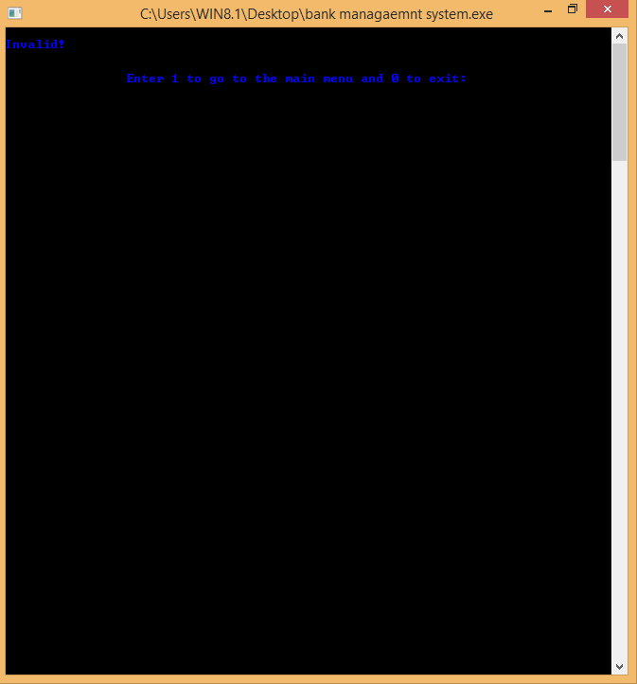

**For wrong account no when finding account**

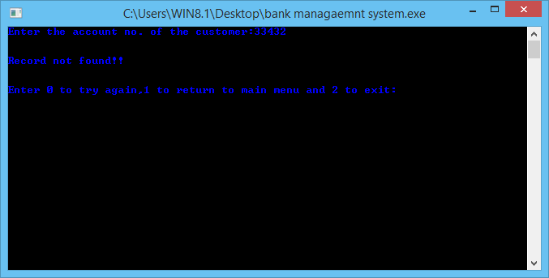

**RESULT:-**

**Comparing with the existing system:-**

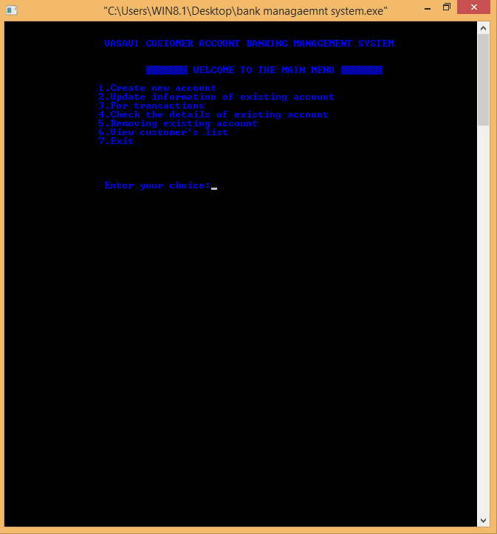

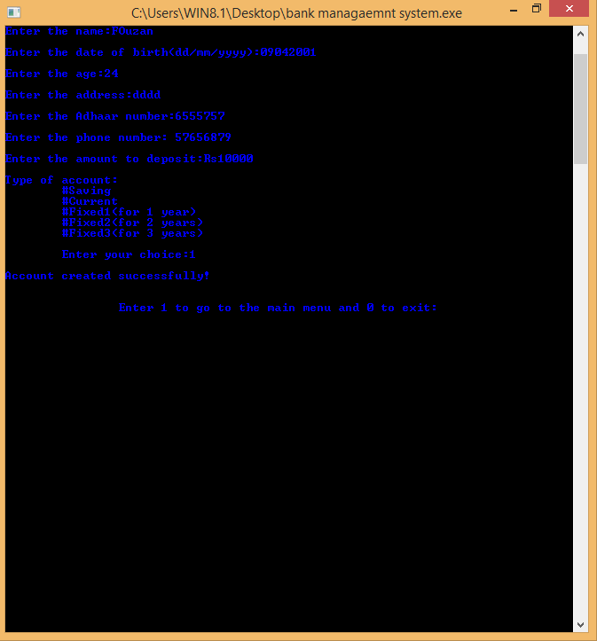

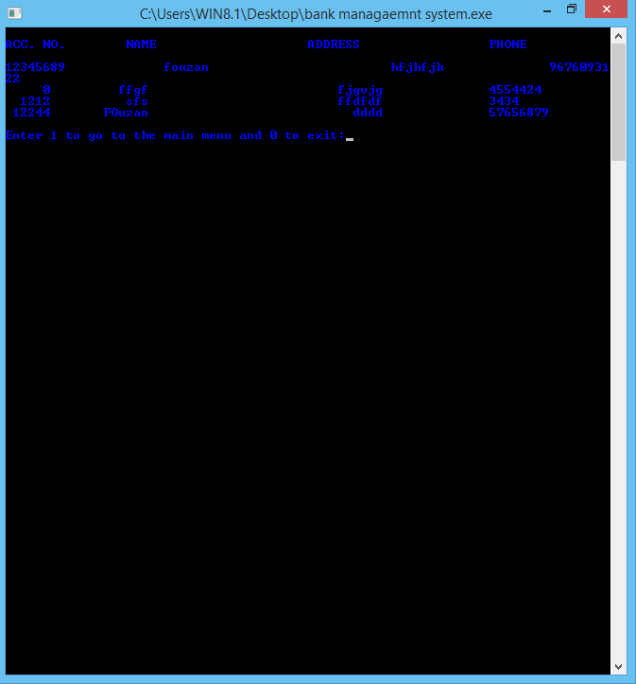

**Additional Learning**

This project is a great experience to learn many new things. It was very helpful in improving our coding skills and concepts related to C. Teamwork is another important skill in which we improved ourselves from sharing our ideas to presenting the final project. It helped us in organizing our thoughts, planning our work, time management, communication skills and learning together. Working as a team also helped in completing the work in less time and in more efficient way and sharing the workload eases the burn out.

Self-learning is another important aspect which we learnt while working for this project. We learnt many new concepts and different ways of approach to the problem, fixing the errors, debugging. We also had a thorough revision of the concepts and made our basic even stronger It also helped us to be more creative in various steps of its development. It is an opportunity to enhance our skills.

**Discussion and Future Work**

It is very useful and be used with a lot of various other coding languages and it helps us know alot about how bank works

**Reference:-**

We have used the following site for gathering the important information, and to consider the important data.

<https://www.w3schools.in/c-tutorial/>

<https://www.tutorialspoint.com/cprogramming/index.htm>